**Mozhi Amudham**

Mozhi Amudham, focusing on the technical aspects and considerations for each feature.

**1. Text Adventure:**

* **Concept:** A text-based game where users make choices that affect the story's progression. This is a great way to introduce vocabulary and basic grammar in context.
* **Implementation:**
  + **Game Engine/Framework:** Consider using a lightweight game engine like Twine (for pure text adventures), or a framework like Inform 7 (specifically designed for interactive fiction). These tools often have built-in support for variables, conditional logic, and other game mechanics, making it easier to manage the story's complexity.
  + **Data Storage:** Store the adventure's content (text, choices, vocabulary) in a structured format like JSON or XML. This allows for easy editing and localization.
  + **Vocabulary Integration:** As users progress, introduce new vocabulary words within the game's narrative. Provide definitions, pronunciations (text-to-speech could be integrated here), and perhaps even mini-quizzes to reinforce learning.
  + **Writing in the New Language:** Incorporate tasks where users must construct sentences or short paragraphs in the new language to advance the story. This could involve typing or selecting words from a provided list.

**2. Sentence Constructor (Chat Agent):**

* **Concept:** A chatbot that guides users through the process of translating sentences, rather than simply providing the answer.
* **Implementation:**
  + **Natural Language Processing (NLP):** This is the core of this feature. You'll need NLP capabilities for:
    - **Language Detection:** Identify the user's native language and the target new language.
    - **Sentence Analysis:** Break down the sentence into its constituent parts (subject, verb, object, etc.).
    - **Clue Generation:** Provide hints related to grammar, vocabulary, or sentence structure without giving away the full translation. This is the most complex part and will require careful design.
    - **Error Detection:** Identify common translation mistakes and provide feedback.
  + **Dialogue Management:** Design the chatbot's conversation flow. It should be able to handle user input, provide clues, and track the user's progress.
  + **Platform:** Consider using a chatbot platform like Dialogflow, Rasa, or Amazon Lex. These platforms provide tools for building and managing conversational agents, including NLP capabilities.
* **Example Interaction:**
  + **User (Native Language):** "How do you say 'The cat sat on the mat' in Spanish?"
  + **Chatbot:** "Let's start with 'the.' Do you know the Spanish word for 'the' in this context?"
  + **User:** "el?"
  + **Chatbot:** "Close, but 'el' is masculine. 'Mat' is 'alfombra' (feminine). Think about the feminine form of 'the.'"
  + **(Continues until the user constructs the correct sentence.)**

**3. Speech to Learn:**

* **Concept:** Users practice pronunciation by speaking words in the new language.
* **Implementation:**
  + **Automatic Speech Recognition (ASR):** This is crucial. You'll need an ASR service that can:
    - **Accurately transcribe speech:** Even with different accents and pronunciation errors.
    - **Provide confidence scores:** Indicate how confident the ASR engine is about its transcription. This can be used to give feedback to the user.
    - **Support the target language:** Ensure the ASR service supports the new language you're teaching.
  + **Evaluation Metrics:** How will you determine if the user's pronunciation is correct? This could involve comparing the transcribed text to the correct pronunciation, analyzing phonetics, or using a combination of techniques.
  + **Real-time Feedback:** Ideally, provide immediate feedback to the user on their pronunciation.
* **ASR Solutions:**
  + **Cloud-based APIs:** Google Cloud Speech-to-Text, Amazon Transcribe, Microsoft Azure Speech to Text. These are generally good for scalability and accuracy.
  + **Open-source options:** Kaldi, Mozilla DeepSpeech. These require more setup and maintenance but offer more control.
* **Performance:** Inference time under 1 second is challenging but achievable with optimized ASR models and good network connectivity. Focus on optimizing the audio processing pipeline and using efficient ASR APIs.
* **Cost:** Cloud-based ASR services typically charge per audio minute. Calculate the estimated usage based on 10,000 concurrent users and average session length to get an idea of the cost. Open-source solutions have upfront costs (hardware, development) but might be cheaper in the long run. Consider tiered pricing and usage limits.

**Key Considerations for all Features:**

* **User Interface (UI) and User Experience (UX):** A clean and intuitive interface is essential for language learning apps.
* **Content Creation:** High-quality, engaging content is crucial. Consider hiring language experts or collaborating with language learning resources.
* **Scalability:** Design the app to handle increasing numbers of users and content.
* **Localization:** Plan for easy localization of the app into different languages.
* **Testing:** Thorough testing is essential, especially for the ASR feature, to ensure accuracy and performance.

**Architecture Design**

[**https://app.eraser.io/workspace/KgAM9Bup1iTn1pL5v6mC?origin=share**](https://app.eraser.io/workspace/KgAM9Bup1iTn1pL5v6mC?origin=share)

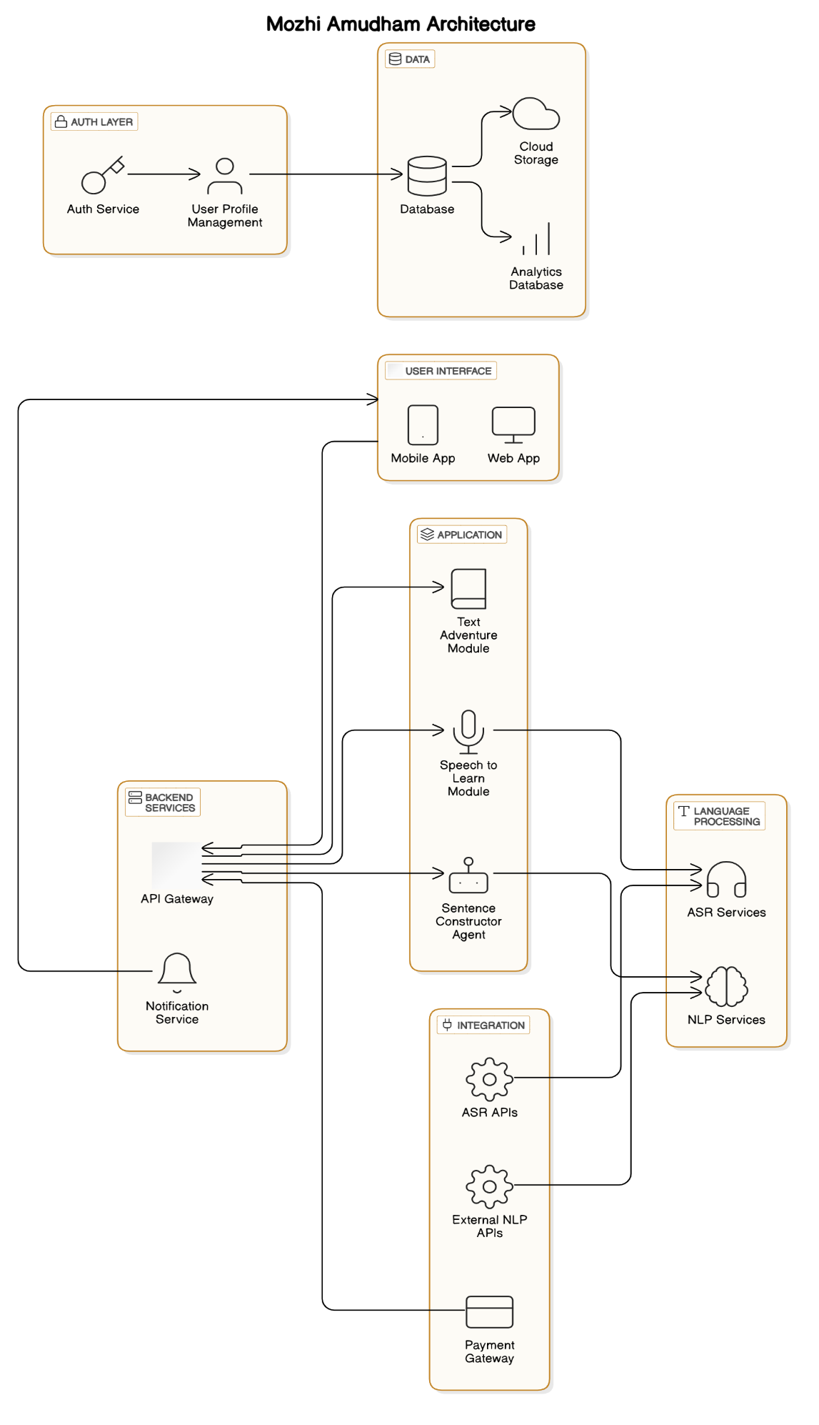

**1. User Interface Layer**

* Mobile App (iOS and Android):
  + Provides an interactive platform for users to engage with the learning content on their smartphones and tablets.
* Web App:
  + Offers access to the application's features via web browsers, ensuring accessibility across devices.

**2. Application Layer**

* Text Adventure Module:
  + Engages users with interactive stories that gradually introduce new vocabulary in the target language.
  + Implements decision-based narratives requiring user input in the new language.
* Sentence Constructor Agent (Chatbot):
  + Acts as a teaching assistant guiding beginners in constructing sentences.
  + Provides hints and feedback without giving direct translations, fostering active learning.
* Speech to Learn Module:
  + Allows users to practice pronunciation by attempting to say vocabulary words presented by the app.
  + Provides immediate feedback on pronunciation accuracy.

**3. Authentication & Authorization Layer**

* Auth Service:
  + Manages user authentication processes, including login and registration.
  + Ensures secure access to user profiles and learning progress.
* User Profile Management:
  + Stores user preferences, progress tracking, and personalization settings.

**4. Language Processing Layer**

* Natural Language Processing (NLP) Services:
  + Powers the Sentence Constructor chatbot with language understanding capabilities.
  + Analyzes user inputs to provide contextual hints and corrections.
* Automatic Speech Recognition (ASR) Services:
  + Converts spoken words into text for the Speech to Learn module.
  + Evaluates pronunciation and fluency.

**5. Backend Services Layer**

* API Gateway:
  + Serves as a single entry point for all client requests.
  + Routes API calls to the appropriate backend services.
* Notification Service:
  + Sends push notifications, reminders, and motivational messages to users.
  + Keeps users engaged and informed about new content or features.

**6. Data Layer**

* Database:
  + Central repository for user data, learning content, and application configurations.
  + Utilizes scalable databases like MongoDB or PostgreSQL.
* Cloud Storage:
  + Stores media files such as audio recordings, lesson materials, and images.
* Analytics Database:
  + Collects usage data and performance metrics.
  + Supports data-driven decisions for app improvements.

**7. Integration Layer**

* External NLP APIs:
  + Integrates with advanced language processing services for enhanced capabilities.
  + Options include services like Google's Natural Language API or OpenAI's language models.
* ASR APIs (Speech-to-Text):
  + Leverages services like Google Cloud Speech-to-Text or Amazon Transcribe.
  + Critical for achieving the sub-1-second inference requirement.
* Payment Gateway:
  + Handles secure processing of in-app purchases and subscription payments.
  + Supports multiple payment methods for user convenience.

**Scalability and Performance Considerations:**

* Automatic Scaling:
  + Utilize cloud services with auto-scaling features to handle 10,000+ concurrent users.
  + Ensure the ASR services are optimized for high concurrency and low latency.
* Caching Mechanisms:
  + Implement caching for static content and frequently accessed resources to reduce load times.
* Load Balancing:
  + Distribute incoming network traffic across multiple servers to ensure reliability and uptime.

**Cost Optimization Strategies:**

* Efficient ASR Solutions:
  + Explore cost-effective ASR options like deploying open-source models using TensorFlow or PyTorch on your servers.
  + Consider batch processing for less time-sensitive speech recognition tasks.
* Resource Management:
  + Monitor resource usage and optimize server instances to balance cost and performance.
* Usage-Based Billing Models:
  + Negotiate with service providers for billing models that align with your usage patterns.

**Security Measures:**

* Data Encryption:
  + Encrypt sensitive data both in transit (using TLS/SSL) and at rest.
* Regular Audits and Compliance:
  + Perform security audits and ensure compliance with data protection regulations like GDPR or CCPA.
* Secure Authentication:
  + Implement multi-factor authentication for enhanced account security.

**Additional Features to Enhance Learning Experience:**

* Gamification:
  + Introduce points, badges, and leaderboards to motivate users.
* Social Learning:
  + Enable users to interact, share progress, and encourage each other.
* Personalized Learning Paths:
  + Use AI to adapt the difficulty and content based on user performance and preferences.

**Next Steps and Recommendations:**

* Prototyping:
  + Begin with a minimum viable product (MVP) focusing on one key feature, such as the Sentence Constructor chatbot.
* User Testing:
  + Conduct usability testing with a small user group to gather feedback.
  + Iterate on the design based on user insights.
* Technology Stack Decision:
  + Frontend: Consider React Native for mobile apps to maintain a single codebase for both iOS and Android.
  + Backend: Use Node.js or Python (Django/Flask) for scalable backend development.
* Continuous Integration and Deployment (CI/CD):
  + Set up CI/CD pipelines for streamlined development and deployment processes.
* Monitoring and Analytics:
  + Implement tools like Google Analytics or Mixpanel to monitor user engagement and app performance.

**Exploring ASR Solutions:**

* Open-Source ASR Engines:
  + Mozilla DeepSpeech: A TensorFlow-based speech-to-text engine that can be trained on your dataset.
  + Kaldi: A toolkit intended for use by speech recognition researchers.
* Custom Models:
  + Train custom ASR models tailored to the specific accents and pronunciations of your target user base.
* Edge Computing:
  + Utilize edge computing to process ASR tasks on the user's device, reducing server load and latency.

**Delving Deeper into User Engagement:**

Understanding what keeps learners motivated is crucial. Consider incorporating:

* Adaptive Learning Algorithms:
  + Tailor content difficulty based on user progress.
* Cultural Context:
  + Include lessons that teach cultural nuances and idiomatic expressions.
* Feedback Loops:
  + Provide immediate, constructive feedback to help users correct mistakes.